Q1.
Answer is B.

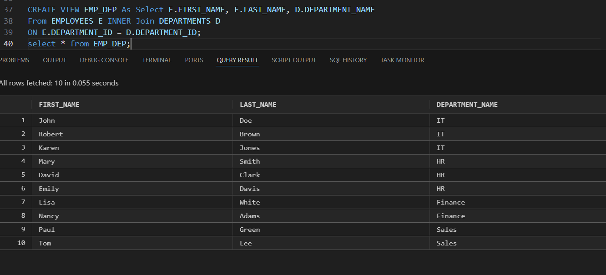

A: should uses a cross join without a join condition.

B: Correct: Uses JOIN with the proper join condition. Result: Shows each employee with their correct department.

C: Incorrect.

D: Incorrect.

Q2.
Answer is C.

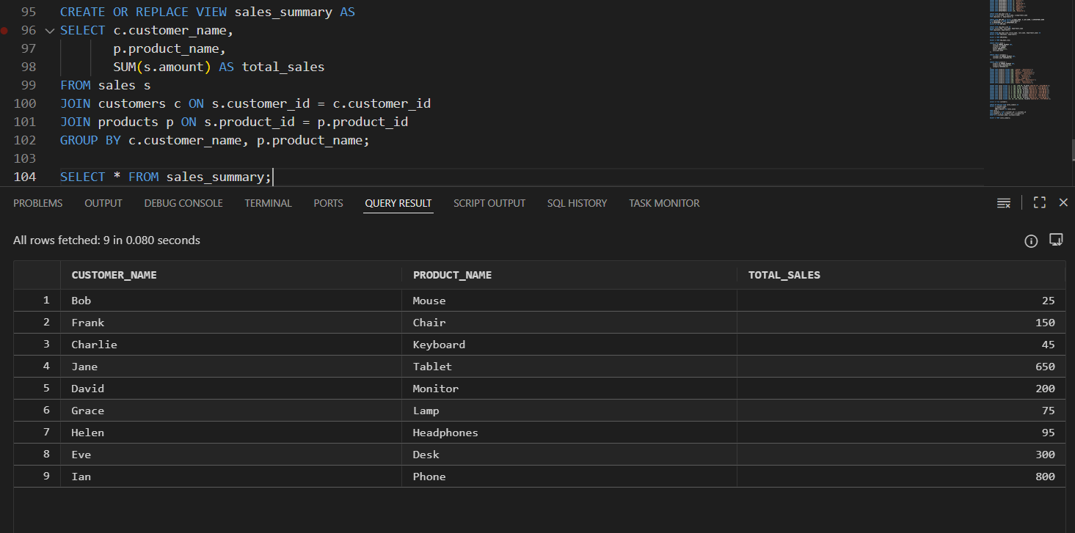

A: Syntax error: You cannot add a column to a view this way.

B: Invalid syntax: SQL does not have any MODIFY VIEW command.

C: Correct. This is the only valid way to “update” a view’s structure.

D: Invalid.You cannot UPDATE a view definition with UPDATE.

Q3.
Answer is B.

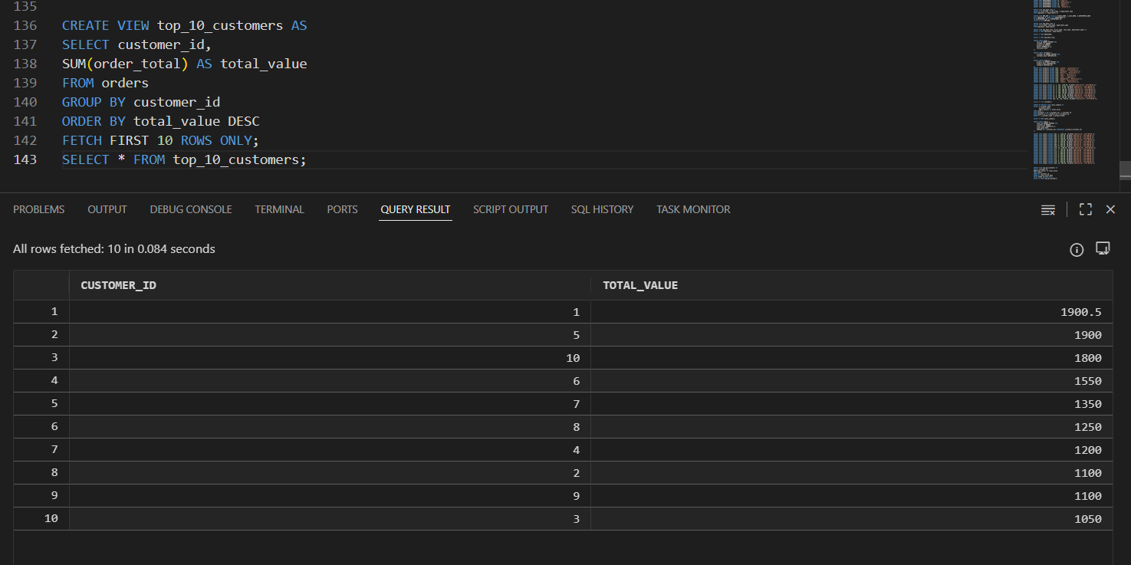

A: Invalid. The LIMIT clause is not supported in Oracle SQL.

B: Valid. Work in Oracle.

C: Incorrect syntax.

D: Work in SQL Server. Invalid in Oracle.

Q4.
Answer is D.

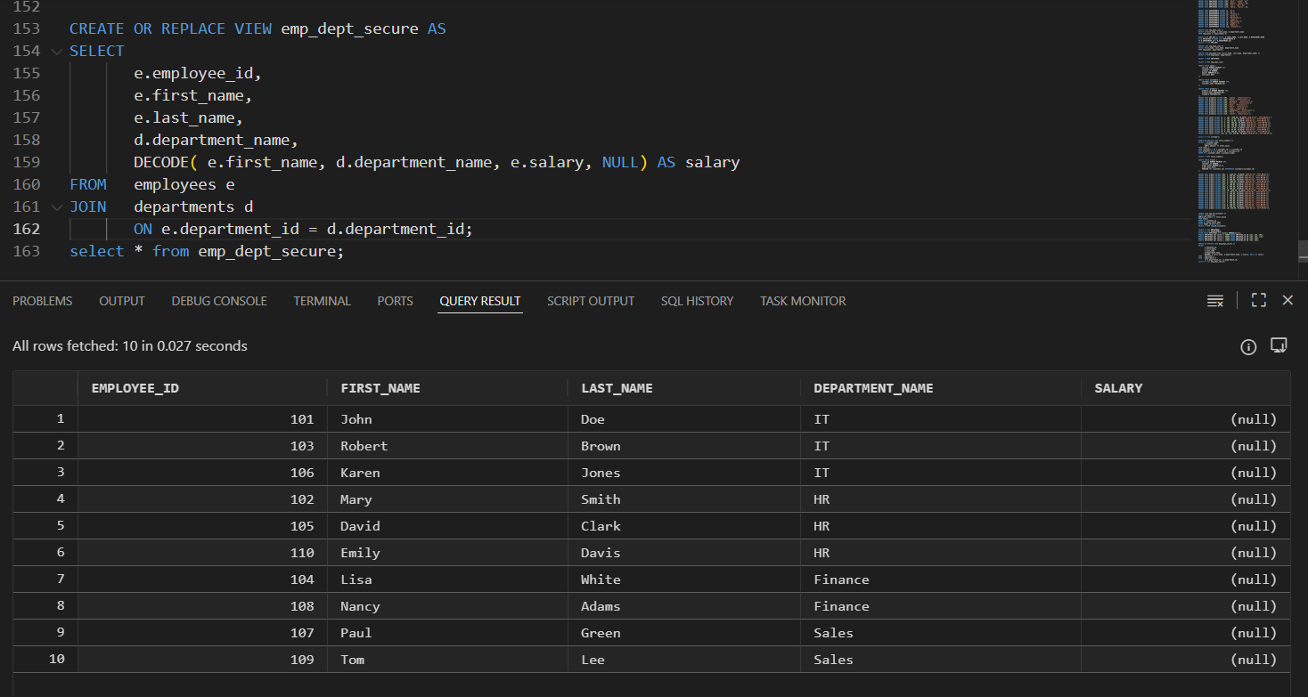

A: Requirement is only to hide salary, not entire rows.

B: Incorrect. But correct logic for hiding salary.

C: Incorrect. All users can still see all salaries.

D: Correct. All employee and department rows are visible. Only the salary column is masked for unauthorized users.Compact and standard for Oracle.

Q5.
Answer is B.

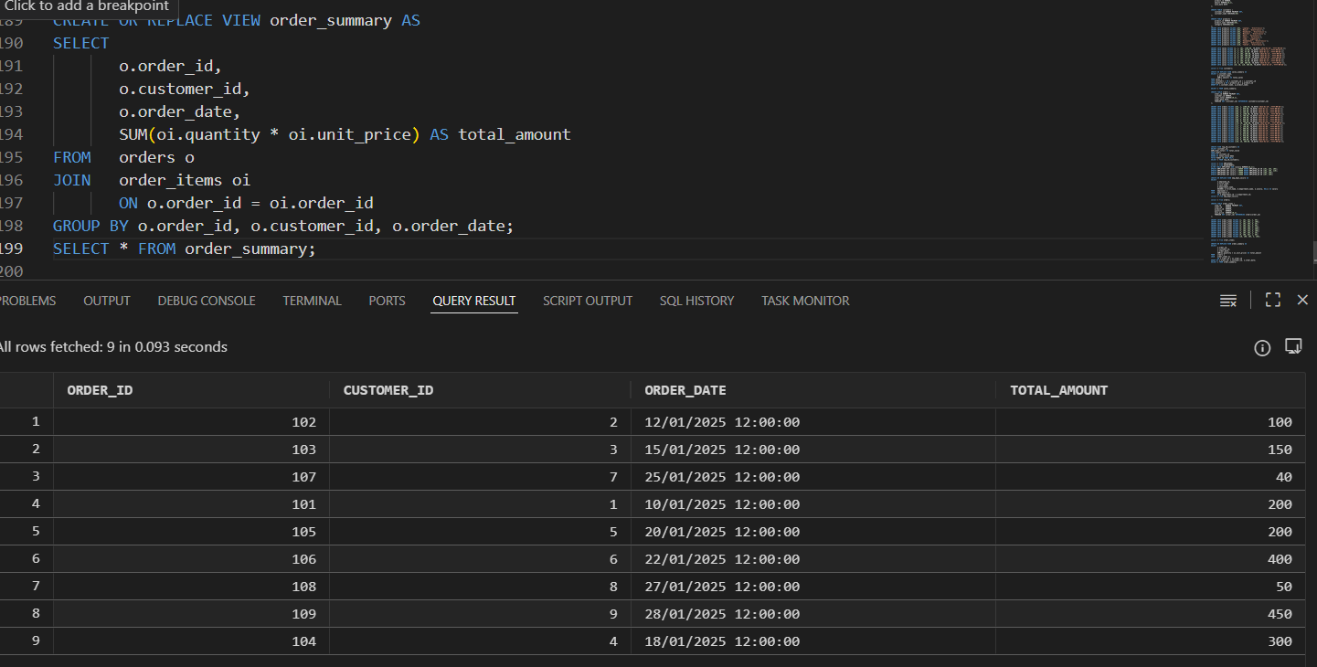

A: Must include a WHERE clause (WHERE o.order_id = oi.order_id) or use JOIN explicitly.

B: This is clear, efficient, and the most standard SQL syntax used in Oracle, MySQL, and SQL Server.

C: Technically correct, but less efficient.

D: Works well for reporting, also correct.

Q6.
Answer is B.

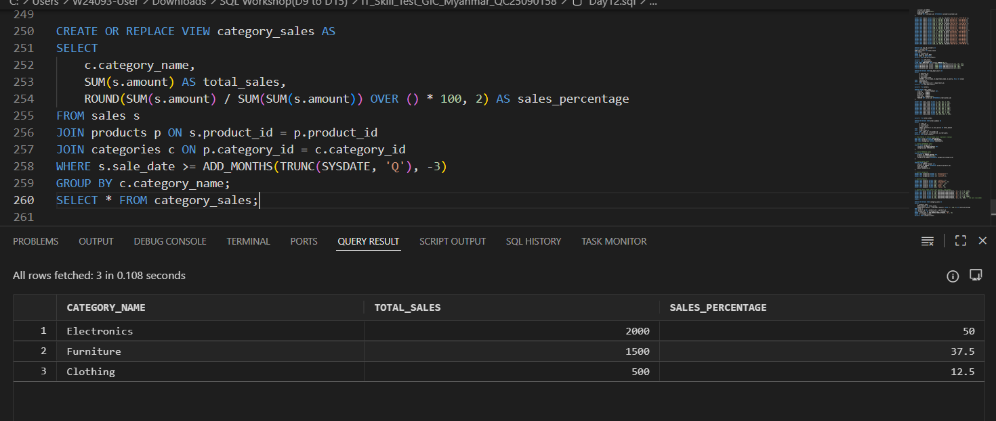

A: Almost correct (missing ROUND).

B: Correct.

C: Wrong denominator scope.

D: Invalid use of HAVING.

Q7.
Answer is A.

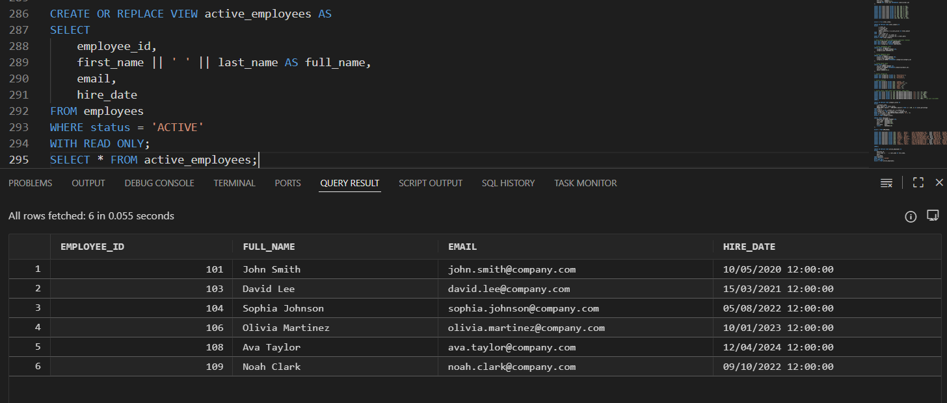

A: Correct Oracle syntax, correct concatenation, proper read-only restriction.

B: Wrong use of CONCAT, uses WITH CHECK OPTION instead of WITH READ ONLY.

C: Works, but Option A is cleaner and preferred.

D: Not read-only.

Q8.
Answer is A.

A: Because the query result is stored in the database,queries can be executed much faster, CPU load is reduced. The store data can be refreshed as needed. Therefore, using a Materialized View is the best solution for report views that have performance issues.

B: This is a regular view, not materialized.

C: Overly complex and inefficient.

D: Still a regular view,same performance problem as B.

